New Mexico Proud: Exploring Equitable Education Outdoors
Saturday, December 7, 2019
Convened by the Environmental Education Association of New Mexico
at the Los Duranes Community Center

Goals for the day:
1) Connect people interested in outdoor and environmental learning, access to the outdoors, and social impact
2) Begin conversations that will lead to the development of a shared multi-year systems change agenda to transform education and provide equitable access to the outdoors for all youth
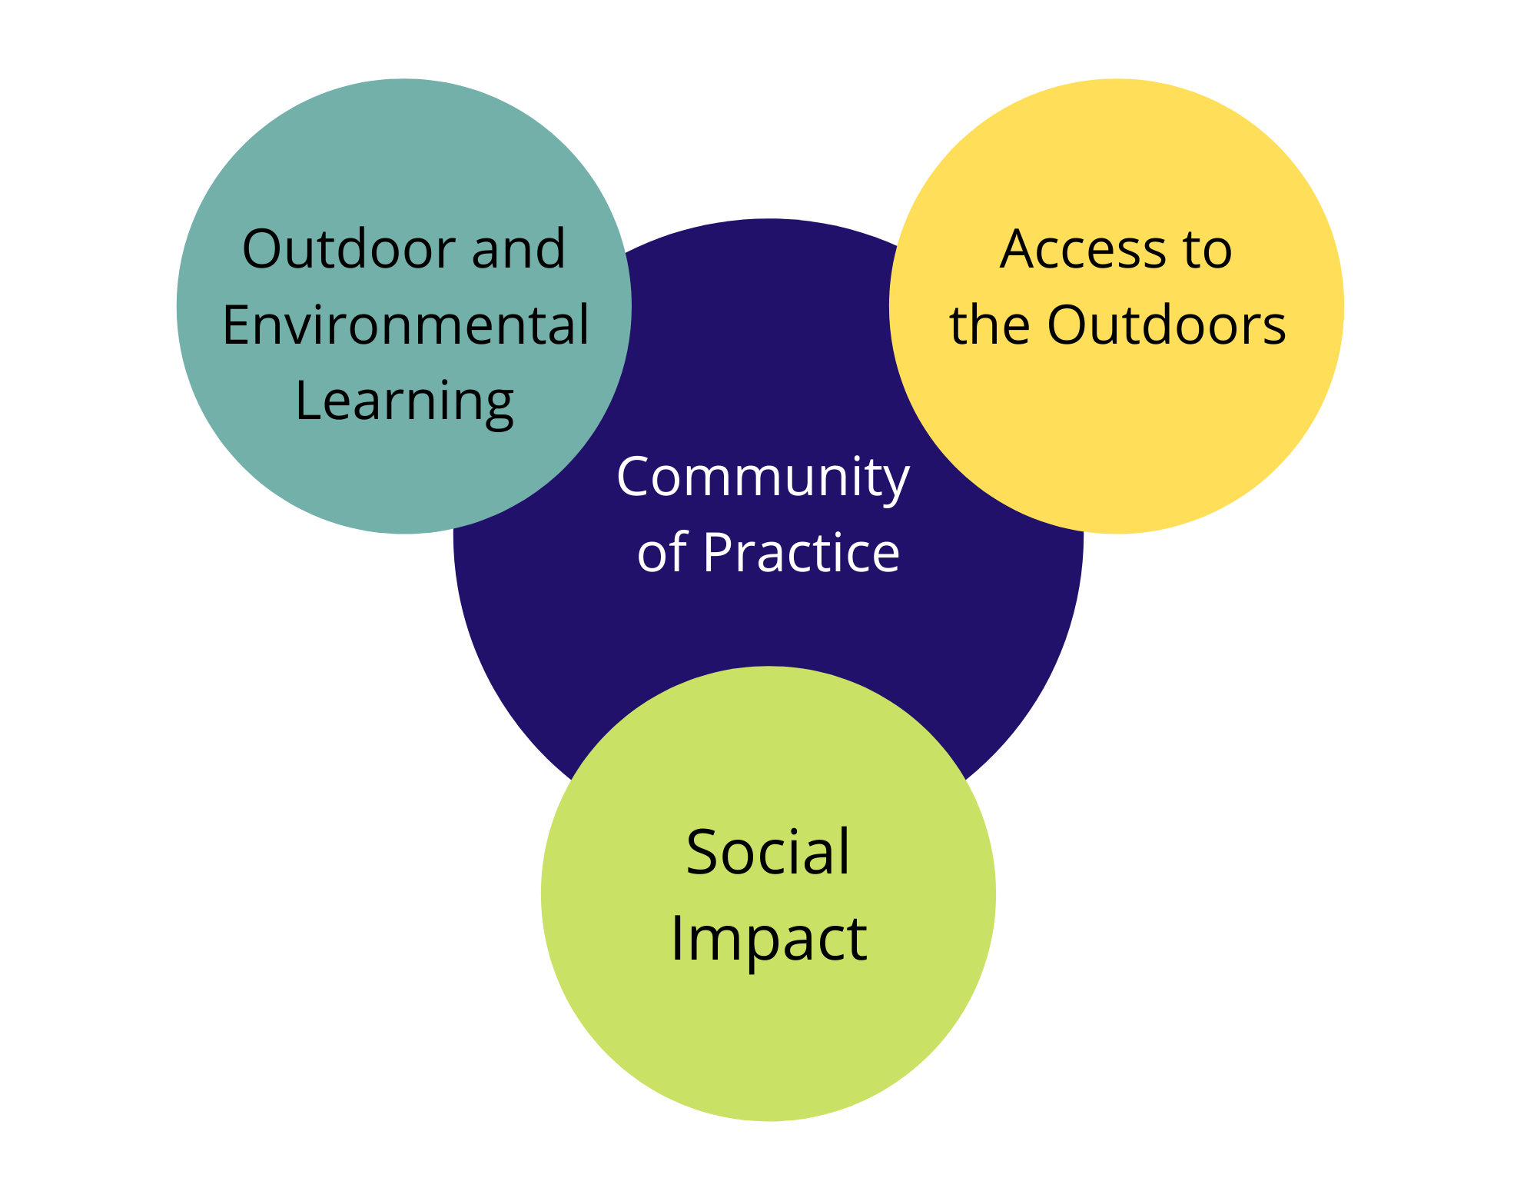
9:00 Check-in
9:15Welcome and overview of the day
9:45 A Dialogue on Equitable Education Outdoors with
NM Leaders
● Carl Colonius (Colonius Consulting and Co-Founder, Rocky Mountain Youth Corps)
● Joe Garcia (Farm Education Director, La Plazita Institute)
● Axie Navas (Director, New Mexico's Office of Outdoor Recreation)
● Sarah Wood (Director, New Mexico Youth Conservation Corps)
10:30 Break
10:45 Group Think Sessions: Facilitated smaller group discussion on outdoor/environmental learning, access to the outdoors, and social impact ending with report outs and next steps
12:45Final wrap-up

1:30 - 4:30p.m. Lunch and hike in the bosque at the Rio Grande Nature Center

Thank you to our generous supporters of this event including the Lineberry Foundation, McCune Charitable Foundation, Project Learning Tree, andThe Wilderness Society!!! We appreciate their generosity in supporting the community in building a movement centering on people.

Participants engaged in small group facilitated discussion on the following topics:
- Outdoor and environmental learning
- Access to the outdoors
- Social impact

Groups answered the following two questions about each topic:
- How do you define this area?
- What does it look like if done equitably?

HIGH LEVEL REPORT OUTS AT THE END OF THE DAY (more detailed notes below)

OUTDOOR and ENVIRONMENTAL LEARNING
- Need to be part of everything we need and intentional and relevant and adaptable
- Focused on access (in all ways including spaces and learning)
- Outdoor learning is empowering
- Exchange of learning “Learning as a dialogue.” And “Intersectional – across experiences and across sectors.”
- Representation – creating space for more perspectives and exploring “how do we bring in other voices?”
- Village conceptualization
- Additional resources needed for teachers to know how to interact

ACCESS TO THE OUTDOORS
- Historical trauma, history of the land, limited resources need to be discussed
- What does it mean to be outdoors? “Patagonia and REI don’t define what being outdoors means.”
- Meet people where they are at
- Supporting and training for teachers

SOCIAL IMPACT
- There are many layers of knowledge, oppressive forces, and impacts
- Support leaders within communities
- Social impact as a process instead of merely outcomes whose metrics have bias
- When using metrics, how do we define cultural relevancy and reflection is a broader lens than evaluation (social/emotional, community metrics)
- Broaden the paradigm from education to learning
- This is rooted in systems thinking

OUTDOOR and ENVIRONMENTAL LEARNING

How do you define this?

Needs to be adaptable
- To environmental conditions
- Based on on need, specific situations
- Embrace serendipity

- Personal connection
- Multiple perspectives
- Enriching
- Immersive
- Holistic and intentional
- Relevant
- Authentic
- Experiential
- Project-based learning
- Connections to environment and place (historic and current)
- Learning -> wisdom
- Highly variable
- Fun, playful
- Self-directed, student-centered, inclusive
- Accessible to all learners
- Risky, boundary pushing
- Empowering
- Multi-generational
- Connection to what sustains us - water, food, etc.
- Any place
- Sense of wonder, emotional, exploration
- Dialogues!

Can be called many things

Lack of technology and other distractions OR really intentional use of technology
AND
Structured and unstructured time

Challenge to adopt abandoned spaces among us
Increase comfort with being uncomfortable
Apply learning
Provide tools for engaging in big issues like climate change, pollution, etc.

Farm to School is actively promoting local procurement of food, school gardens, and nutrition education. Sustainable agriculture is part of EE.

SAFETY IS IMPORTANT

Would money for equipment at schools (like outdoor gear) help with equity?

How does this look if it’s done equitably?

SAFETY
Physical
Spiritual
Emotional
Open, honest conversations around how groups feel and use and be in outdoor spaces

Preparing (physically, mentally, and with resources) students, teachers, schools, parent for the experience
Not just logistical, but other barriers (economic, etc.)

Think of creative partnerships and models to empower students to engage in environmental choices, actions, etc.

Need to work to bridge the gap between indoor and outdoor classrooms

Support and create PD for teachers and help to integrate EE into the school itself

Focus on access
Meeting local needs, local places

Training on anti-oppression and trauma

Gear shaming leads to exclusion and bias

In response to ⅓ of known EE programming in New Mexico happening in Albuquerque: This speaks to EE as a philosophy/pedagogy that can be applied to every place, space, subject, etc. There can be a different way of looking at EE in order for every community to be considered as having EE experts.

ACCESS TO THE OUTDOORS

How do you define this?

Honoring and appreciating the history of spaces and people

Outdoor experiences can be simple!

Looking for spaces already available
Requires top-down value of EE
Honors elders and role models who are already there
Prepares teachers to teach EE

Every day, every action
Systems change

HUMANS ARE ALWAYS PART OF THE ENVIRONMENT. (Make sure EE includes all environments)
Equitable (not equal) distribution of $

Communities outside of Abq/Santa Fe

Creating space in field for more diversity in professionals, more diverse definitions of outdoor education

Empowerment and systems change!

- Representation
- Education spaces that include critical analysis of trauma and race and history
- Levels of access to support access in every part of your life
- Language!
- Pay equity
- Systemic change
- Natural learning and changing power dynamics
- Out of school learning

How does this look if it’s done equitably?

Recognize that culture can influence ability to access outdoors
Need culturally-relevant experiences

Power of story telling
- Shift balance away from elite to inclusive
- Stories must reflect cultures

EE should be holistic, all education is EE, build relationship to environment in every aspect of education, deeper and broader learning through outdoor experiences

School grounds can often fulfill “outside” access
Example: Albuquerque Public Schools architects asked for input from science teachers

Teachers are afraid to do it, lacking admin support
Teachers need tools and ideas to continue conversation

Access not necessarily available at home
Focus on building natural environments within urban centers
Reach people where they are
Older folks are more comfortable outdoors? Often not very involved

Create “lending library” of gear?

Outdoor spaces are often closed during school year
Inadequate funding
Early childhood sites must be licensed through CYFD leading to limitations

Families don’t show up (sometimes undocumented, need to do better to meet families on what they need)

* Need to meet families on their own terms and turf. Target populations are often not at the table. How do we move the table there?

Agencies need cooperation from underserved communities.

Equity means changing the foundation
- Hard issues, but need to be discussed
- Easier to work with existing partners
- Expand outdoor education beyond birds and bees into big picture
- Asky why questions

Students ask what’s the point of being outdoors
Students and teachers are afraid of outdoors <-> Teacher training can help reduce fear

Need comfortable/passionate facilitators
Need start outside experiences early to maintain early love of nature
Outdoor tasks viewed differently than outdoor experiences

Some larger cities have programs and intentional spaces to encourage outdoor experiences which are harder to replicate in smaller communities.

Equitable access to role models as well as experts.
Need to acknowledge historical trauma (lynching, kidnapping)

Focus tends to be on inside spaces as sources of “solutions” and “power”

Outside exposure => growth and realization
Representation matters

Move popular culture outdoors
- Cultivate sense of duty and pride in outdoor activities
- Acknowledge student despair about global warming
- Bring an idea/feeling of joy
- Think about what students have, not about what they don’t
- Create positive emotion
- Spark further exploration

Need to involve and address communities (not just students)

Redefine “outdoors”.
Need to override culture of fear about outdoors.
Move past consumerism.
We don’t know what we don’t know.

Public Lands:
- USFS closures limit access, need willingness to discuss
- How do we access decision makers?
- 2 Federal bills in progress to enhance outdoor access
- Insufficient $ to keep public lands open year-round
- Outside access not necessarily outdoors
- Access passes don’t actually result in outdoor experiences
- Agencies don’t communicate well to communities
- PLIC has resources
- Rules and fees discourage outdoor use

Partnerships with local and federal agencies needed.

SOCIAL IMPACT

How do you define this?

Social impact as a process is grounded in systems thinking. This means that to explore impacts means being willing to look at multiple factors that contribute to impact.

Learning and applying, community level, empowerment, systems change. Si se puede.

- Social impact looks different, scaffolds.
- Wilderness exists in our own bodies
- “Bringing” nature/wilderness
- CHANGING narrative and hierarchy about what constitutes outdoors
- Social impact for students/self/organizations
- Embracing community knowledge
- LANGUAGE and VOCABULARY can be a hindrance or tool
- Process -> immersion
- Accountability -> personal responsibility
- Local champions -> emergent

- Changing behavior
- Providing opportunities
- Community wide
- Not just recreator (tied to consumption)
- Radical (more radical access)
  - Altering relationships to place
- Connections/ true dialogue
- Provide/create tools to make make meanings, building trust

Community specific/LISTENING!
Varies by age group
Advocacy - representing/providing a voice to the user
Let the outcome com organically
Monety to support community engagement so that people with ability can listen (listen emphasized and connected back to community)
ID social impacts that have already been made is an important step also

Need to define “outdoors” and “outside” - two different definitions
Need to talk about barriers AND dream solutions

- Learning, absorbing, sharing
- Reconnecting
- Representation (and underrepresentation)
- Compassion
- Creating opportunity and space
- Outcomes: increased vitality, heath, joy !

- Elders and youth connecting, part of community, value everyone’s input
- Macro-societal shifts and individual shifts
- Awareness of the environment
- Ways people can thrive in face of change
- People can see and articulate connection to natural world

- School gardens, empowers students to be part of food systems. Tool for them to understand where food comes from, create exposure or connection to community
- Longevity and changes in small habit patterns
- Who is represented in the outdoors. Expeditions with international students. Want students to take home lessons from expeditions. Inspire students and encourage others to get outdoors.
- Environmental impact is secondary to social impact. Students are dependent on each other. Opportunities for personal growth in group settings as well as understanding each other.
- Ripple effect from one time experience. Being human. Negative social from top-down, cookie cutter approach. We need individualized approach.
- Need to be equitable instead of equal. Top down and bottom up.
- Are efforts to engage students/communities just steamrolling?
- Need to meet people and communities where they are.

- As a process
- Involves measurable goals
- Evaluation/reflection that’s ongoing
- Reflection that is a wider lens than evaluation
- Includes hard to measure like socio-emotional learning
- Broaden the paradigm of learning
- Starts local - find the champion
- Trust building
- Emergent
- Opportunity for continued change
- Rooted in systems thinking
- Multi-faceted experiences beyond the classroom
- Listen deeply
- Beware of negative social impacts - changing the narrative
- Community leaders as teachers
- Learning, reconnecting, compassion
- Not just kids, community too

Social impact is a slippery topic.
- Systemic exploration
- Inequities are built into the system (immigration, EE, etc.)
- How do we talk to schools about EE?
- Not enough spiritual/emotional impact
- Past, present, future of a space
- Lots of checking in with emotional self

How does this look if it’s done equitably?

Empowering, assessment formula that is more appropriate, community assessment, localizing values, relevant, individualizing, who are you communicating with, what opportunities exist to meet people where they are, safety, relationship building, relational.

- Equity=access/knowing the opportunity
- Responsive and respect what level people are at -> acknowledging historical trauma-> how to heal = equity= growth
- Facilitators being motivated/knowing resources
- System change = to allow autonomy creativity
- Invite facilitators of different community orgs to OE/EE opportunities
- Done in collaboration, not imposed
- Increases access, decreased inequality
- Not imposing experiences, increases opportunity to experiences
- Connects in honest, authentic ways

- Hire in the community where the work is to be done.
- Create an environment that is welcoming and provides an invitation to participate.

If rethinking outcomes, they are not bad in themselves- but having more community input in what they are. Can joy be an outcome?

From an outside view, identifying 1) a problem, 2) a solution, and 3) how we can help TO ->
- Asking the community for 2) an invitation to 3) support them in addressing a problem that has been subjectively defined by the community.

Impacts of conservation community no always positive, how to have difficult conversations as educators, how can we change, honesty about past to be clear about goals, ongoing effects of harms

Need to focus on structures

- Forest schools - how to go beyond the folks who can pay for these experiences
- How to get urban schools - transportation, access to funding
- Bringing the forest to the kids
- Sticks and rocks are ok, ok to touch and experience
- Creating safe spaces
- Challenge to re-green the space

Connecting to land!
Reaching all ages, children teaching children, elders teaching elders
Letting community be those leaders

